Virtual Bounty

Question_1: Nishaanth

Connect the images.  
  
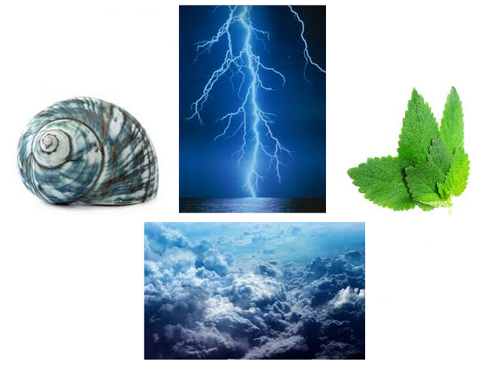



Clues:   
Elementary, Self-Similarity  
  
Answer:

Buddhabrot

Reason:

The first image is supposed to point you to fractals.  
The second image is to point you to buddhism.

Connect the two as buddha fractal and you obtain the buddhabrot.

Question_2: Pradeep



Answer:He’s dead Jim

Reason: Read the last line. It’s a star trek reference. Also, The older version of this broken-page page has ‘he’s dead jim’ as the text instead of Aw Snap!

Question_3:  Gokul

Connect:

X= ....- ---.. .-.-.- ---.. -.... .---- .---- / -.

Y= ..--- .-.-.- ...-- ...-- -.... ....- / .

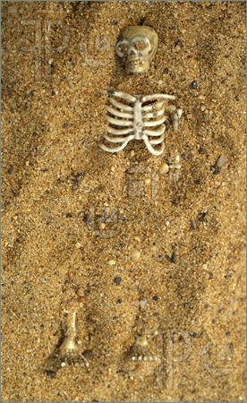

Clues: Morse  
Answer: Mary Magdalene

Reason: The morse converts to the X and Y coordinates of the Louvre. And the skeleton just points to the resting place of a person below the Louvre. That person is believed to be Mary Magdalene, also the wife of Jesus Christ in Dan Brown’s famous book, Da Vinci Code.

Question_4: Kartik Sreenivasan

A religious man always remembers the mystical numbers 25 17.

Clues: The numbers are but a key to the answer. The answer lies in God’s writing.  
 http://www.google.com/search?q=recursion

Answer: is selfish

Reason:

In the movie pulp fiction, Samuel Jackson refers to the bible verse : Ezekiel 25 17.

If you refer the verse. The 25th word is “is” and the 17th word is “selfish”

Question_5: Nishaanth

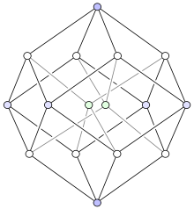

This is the path that you have made.

Alternate timelines will still lead you here.

This is the penultimate answer to your question.

The song of the night.

This is the utopia.

This is a new dawn.

This is reincarnation.

Clues: (The progress tree)  
  
Answer:tesseract  
  
Reason:

The question structure of the entire event is the structure of the Tesseract. It is a 4 dimensional hypercube.

Also Tesseract is a band. Song of the night = Nocturne. Utopia = Eden. Dawn = Sunrise. Reincarnation = Palingenesis.  
These are all songs by the band.

Question_6: Gokul

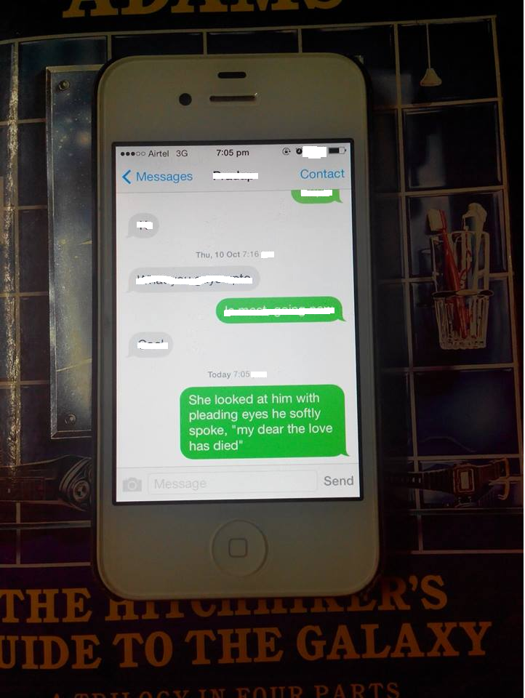  
Clues:Oh the feels.  
Answer: Phantom Vibration Syndrome/Phantom ringing.   
  
Reason:   
The text points to the lyrics of the song “The Ghost Who Walks”. This points further to the comic book hero the Phantom. On googling “phantom” and “phone”, one can obtain the Phantom Vibration Syndrome.

Question_7: Nishaanth

  IN AND OUT AND IN 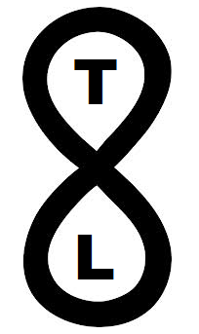

Give us the two words that aptly describe this arrangement.

Clues: Divinity

Answer: infinite possibilities  
  
Reason:

Left image is the golden spiral. Golden spiral implies the fibonacci number related golden spiral. Right image is to indicate the band TOOL.

Google golden spiral and tool and you get the link to their song called Lateralus. In this song the lyrics are sung in a fibonacci fashion. Ascending and descending and ascending and descending(in and out and in and out).

(1) Black,

(1) then,

(2) white are,

(3) all I see,

(5) in my in·fan·cy,

(8) red and yel·low then came to be,

(5) rea·ching out to me,

(3) lets me see.

(2) There is,

(1) so,

(1) much,

(2) more and

(3) beck·ons me,

(5) to look through to these,

(8) in·fi·nite pos·si·bil·i·ties.

(13) As be·low so a·bove and be·yond I im·ag·ine,

(8) drawn be-yond the lines of rea·son.

(5) Push the en·ve·lope.

(3) Watch it bend.

Then as you go IN and OUT and IN, you stop at the line with 8 syllables(right image).   
The words are “infinite possibilities”. That is your answer.

Question_8:Gokul

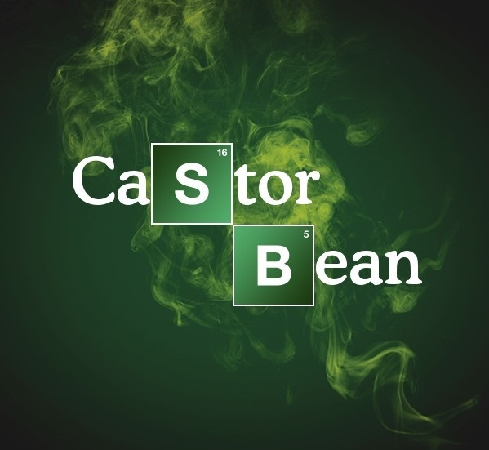

Answer:Ricin

Reason:  
The image a logo in a Breaking Bad fashion. Google Breaking Bad and Castor Bean and you get Ricin. The poison that is used in the show.

Question_9: Sriram & KSB

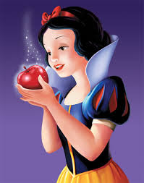

Graham Chapman, Matt Bomer, Jim Parsons

Clues:

Answer: Alan Turing

Reason: The people listed are gay. And snow white is eating a poisoned apple. So they point to a famous gay-convicted person who killed himself with a poisoned apple. Alan Turing himself.

Question_10: Pradeep & KS

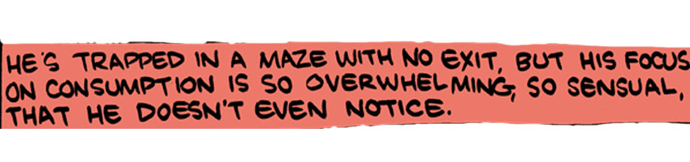

Clues:(Pinky, Inky)

Answer: Pacman  
  
Reason: Answer is pacman. Now, look at the question and take time to figure it out. And then kick yourself.

The clues are the names of the ghosts in pacman.

Question_11: KSB



Clues: PHP, VISA

Answer: Bing

Reason: BING is a recursive acronym standing for BING is not Google. So the picture represents ‘not Google’ (inversion of Google), and PHP and VISA lead you to recursive acronyms.

Question_12: KSB

_______ is a city and separate woreda in Ethiopia. Located in the Semien ______ Zone of the Amhara Region, ______ is north of Tana Lake on the Lesser Angereb River and southwest of the Simien Mountains.

Clues: Three hundred friends went to watch the movie.

Answer: Bounty Hunter

Reason: Gondar is the Bounty Hunter in Dota. Gondar is also a place in Ethiopia. Googling the first line of this passage gives you gondar. And googling gondar gives you Dota.

Else, using the clue, “three hundred (300) friends (Friends)” - get Gerard Butler and Jennifer Aniston. Google them together - Bounty Hunter- the movie.

Question_13: Sriram

When you walk through a storm

hold your head up high

And don't be afraid of the dark.

At the end of a storm is a golden sky

And the sweet silver song of a lark.

Walk on through the wind,

Walk on through the rain,

Tho' your dreams be tossed and blown.

Walk on, walk on with hope in your heart

And ______ _____ ____ _____,

______ _____, ____ ____ _____.

Walk on, walk on with hope in your heart

And ______ _____ ____ _____,

______ _____, ____ ____ _____.

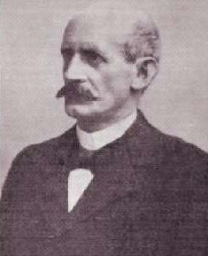

Clues: *hic*  
Answer:Carlsberg  
Tags: Sports,

Reason: YNWA song - refers to Liverpool.

The photo is Johan Kjeldahl, who was working in Carlsberg when he developed the Kjeldahl Method(ring a bell?)

So, Liverpool, Carlsberg…

Question_14: Kartik Sreenivasan

X used Cousin Herbert and Mother Sarah’s names to create Y, an evil bald telepat. Later, after X discarded the names of his cousin and mother and adopted his own, Y was reborn as a true american patriot, feared across the universe as one of the most powerful beings but using that power to fight crime, uphold justice and the truth.

Clues: Rewriting the American Dream.  
Answer: the reign of the superman

Tags: Comics

Reason :

Jerry Siegel used the first name of his cousin Herbert and the maiden name of his mother Sarah to create his pen name “Herbert S. Fine”. Under this name he first wrote the comic “The reign of The Superman”. The Comic was based on a bald telepathic villain who seeked to rule the world. The comic was a failure. Later, with Joe Shuster he rewrote the comic, retaining most of “Superman’s” powers to create the Superman that we know today.

Question_15:Gokul and Pee 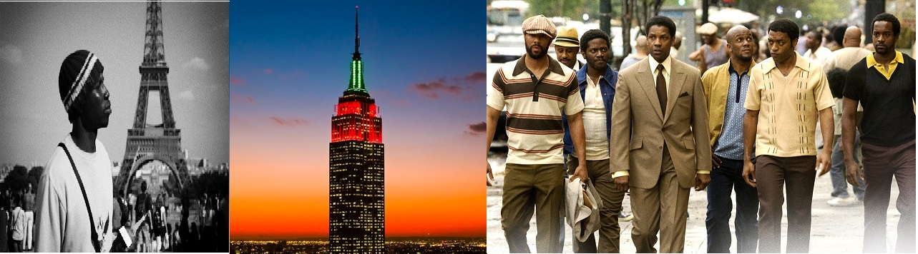Clues:   
Answer:Jay Z/Shawn Corey Carter  
Reason :

The first picture is “Nigga’s in Paris”

The second is the Empire state building in New York- “Empire State of Mind”

The Third is the cover of the movie “American Gangster”

All of Jay Z’s songs and the album.

Question_16: KS

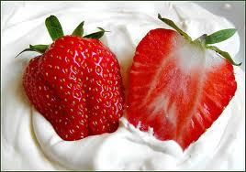            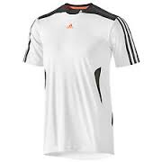

Clues: “Grass is for cows”  
Answer: Wimbledon  
  
Reason : Strawberry and cream, white clothes.(Wimbledon clothing)

Clue -  Ivan Lendl said these words after this semi final losses in Wimbledon in 1983 and 1984.

Question_17: KS  
Ruby Gems

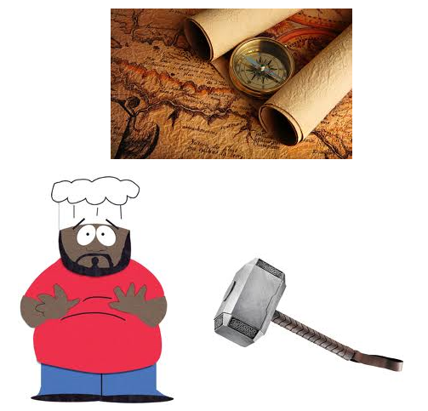

Clues:Cancan  
Answer: Ruby Gems  
  
Reason : South park guy - Chef

Thor’s hammer - Thor

Compass

Clue - Cancan

All are ruby gems.

TRIAL RUN

Question_1: Nishaanth                       7

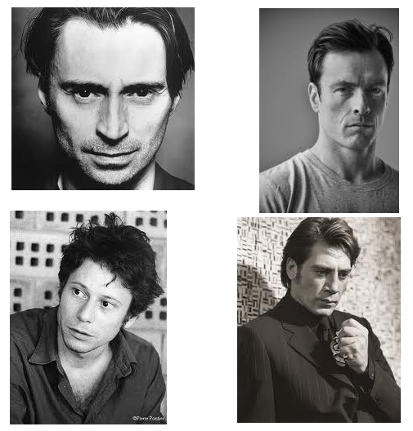

The pictures are in order and yet there’s seems to be something missing.

Give us a better way of identifying the missing person.

Answer: Hannibal

Question_2:                                 1



Clues:  
Answer: Transformers  
Tags:

Reason - Nvidia *Bumblebee* project.

LG *Optimus**Prime*

*Jazz*

*Ratchet*

**Drumroll**

Transformers!

1                                                              2

Question_3: Pradeep & Sriram

Suvra Mukherjee  Carla Bruni



Clio Maria Bittoni                                       Michelle Obama

Clues:  
Answer:Eve  
Tags:

Reason -

The four ladies are the first ladies of their respective countries.

The orb is the Apple of Eden.

Apple, First Lady. => Eve (of Adam and Eve)

Question_4: Kartik Sreenivasan

Ain’t No Fun : 7:31:00

Have a Drink On Me : 4:00:00

Rock ‘N Roll Train : 4:30:00

Dunsfold, Surrey, England : ?

(mins:secs:millisecs)

Clues: Chevrolet Lacetti  
Answer: 1:45.85  
Tags: AC/DC, Top Gear

Question_5: Nishaanth                      6

Dobie Gillis + Thalia Menninger + Zelda Gilroy + X + Y

What do X and Y eat?

Clues: Munchies  
Answer: Scooby Snacks  
Tags:

Reason - An old TV show from which Scooby Doo derived inspiration from. So X and Y are Scooby and Shaggy. So they eat, Scooby Snacks!

Question_6: KSB    4

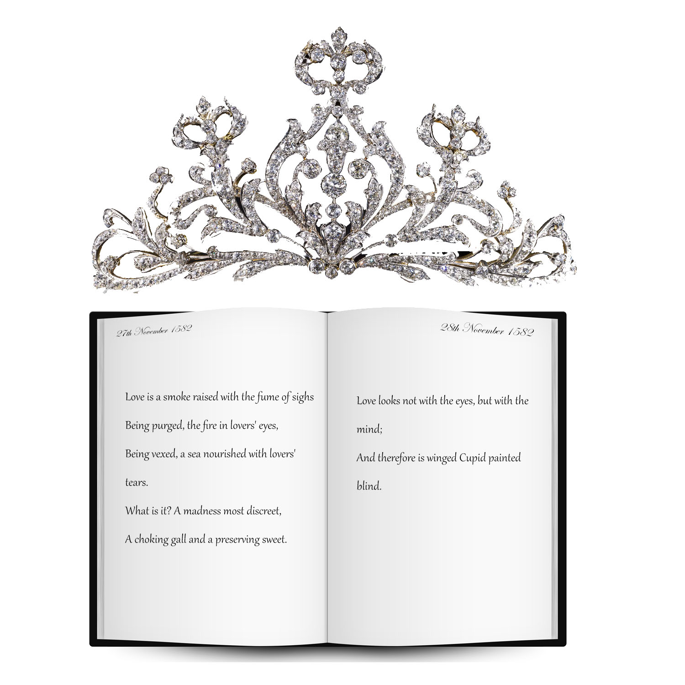

Clues:  
Answer:Anne Hathaway/ Hathaway  
Tags:

Reason - Tiara - Princess

Diary - Diary

Date in the diary - Shakespeare’s marriage

Text in the diary - Reference to Shakespeare

so...Shakespeare’s wife = Lead in Princess Diaries = Anne Hathaway

Question_7:KS                             3

Come crawling faster

Obey your ______

Your life burns faster

Obey your ______

______

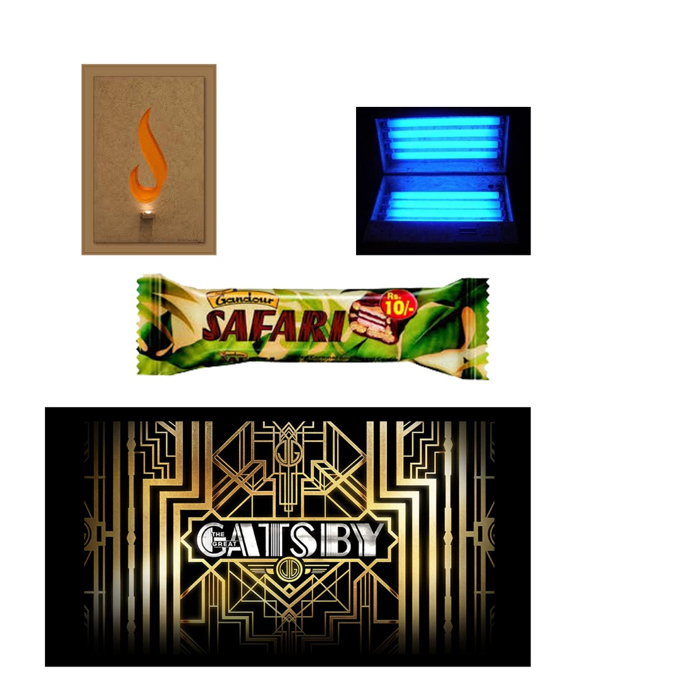

Clues:te  
Answer:Pokeball

Reason - Master of Puppets - Master

UV Light - Ultra

Safari chocolate - Safari

The Great Gatsby - Great

Dusk - company logo - Dusk

All of them, types of Pokeballs.

Question_8: Kartik Sreenivasan

Banned from the races at France due to a change of regulations, In 2014 the Germans return after 16 years, with an Australian at the helm to conquer what was taken from them. They seek to settle an old score, a record set in the _____ in 1971 was broken by the Audi R15 TDI.

Clues: LeMans   
Answer: Porsche 917  
Tags: Google each word :P

Question_9: Nishaanth                             5

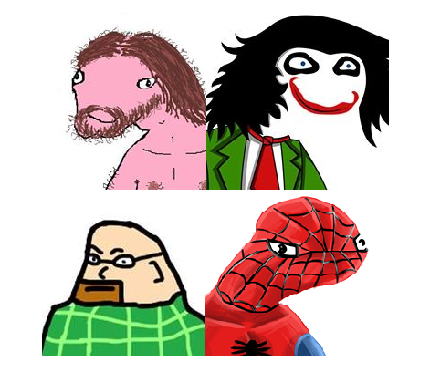

Whut iz teh diseese thut i um suffuring frum?

Clues: Spell it right  
Answer: Dyslexia  
Reason - Obvious.